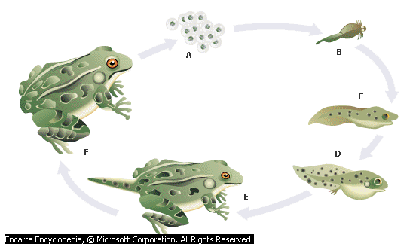
Life Cycle of a Frog
The floating clump of eggs is called frog spawn.
The tadpoles hatch from their eggs.
They have a head, a tail and a body.
The tadpoles are bigger. Their gills begin to shrink.
Now they have hind legs.
Now they have front legs.
The tiny tadpole turns into a tiny frog.
Its tail becomes smaller & smaller until it finally disappears.

